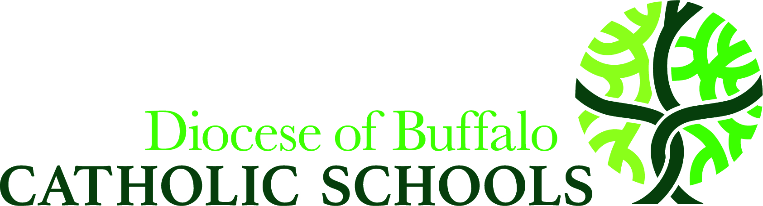

Government Programs and Services for Nonpublic Schools
2022-2023 School Year

*Continued from 2011-2012: Instructional Material Aid Flexibility*

Beginning in the 2011-2012 school year, all schools may now utilize the funds available for textbooks, software and hardware to acquire any of the instructional materials available in each of the four categories – including library materials. Funds for library materials, however, can be used only for library materials.
https://stateaid.nysed.gov/tsl/html_docs/amendments_statutes_tsl_2011_12.htm

New York State Textbook Loan Aid: The State reimburses public school districts for the costs of purchasing and loaning textbooks to children who reside in the district and are enrolled in grades K-12. The allocation is $58.25** per pupil for books. Policies and procedures for ordering textbooks from the public school districts are coordinated through the Department of Catholic Education. **Special Note: If a district spends more on a public school student, then they must spend an equal amount on a non-public student.

Computer Software Aid: Legislation passed in 1984 provides funding to enable public school districts to purchase and loan computer software programs to students attending public and nonpublic schools within the district. The current allocation is $14.98** per student in grades K-12. (see special note under textbook loan)

Computer Hardware Aid: Varies by public school district but on an average it will be about $12.00 per student.

School Library Materials Loan Program: Legislation passed in 1985 provides funding to enable public school districts to purchase and loan library materials to students attending public and nonpublic schools within the district. The current allocation is $6.25** per student in grades K-12. (See special note under textbook loan) Beginning with the 1986-87 school year, both printed and audio-visual materials were included in this program. Your school may also borrow books from the Library Loan System. Please contact the person listed under the school Library Loan System from your area.

Mandated Services: The State reimburses nonpublic schools for the cost of services incurred in meeting mandates which are required by law in connection with testing, evaluating and reporting. Reimbursement is based on expenditures and services provided during the previous school year.

Comprehensive Attendance Policy (CAP) Reimbursement

http://www.p12.nysed.gov/sss/pps/attendance/attendanceQ-A.html - Q#25
The State reimburses nonpublic schools for the cost of services incurred by incorporating a fully comprehensive attendance policy (see link above), including the taking of attendance throughout the day as the students change classes (not including morning attendance). Reimbursement is based on expenditures and services provided during the previous school year.

Smart Schools Bond Act: The 2014-15 Budget included a $2 billion general obligation bond, along with $25 million in 2019-2020 to address inequities in our share of the bond funds, for infrastructure improvements to bring high-speed broadband to schools and the purchase of classroom technology for use by students and teachers. Religious and Independent schools will be eligible for the loan of such equipment on an equitable basis not to exceed $250 per pupil based on enrollment as of April 1, 2014. Contact your public school district of location to inquire as to their progress on adopting a plan for the use of these funds and when you will be involved. Approved plans are listed here: http://p1232.nysed.gov/mgtserv/smart_schools/ApprovedSSIPs.htm

School Safety and Security Funding (NPSE): NYSED provides continued funding for school safety equipment and security for our schools. Spending that occurred after March 31, 2017 will be eligible for reimbursement. Information and reimbursement forms can be found at: http://www.p12.nysed.gov/nonpub/schoolsafety/home.html.

MST Grant: Lawmakers have provided funds to reimburse nonpublic schools for the portion of salaries of Math, Science, and Technology teachers that is devoted exclusively to secular instruction. Reimbursement will be prorated among approved applicants within available funds. Information and reimbursement forms can be found at: http://www.p12.nysed.gov/nonpub/fundingopportunities/home.html#mst.

Academic Intervention Services: Funds are available for schools with Grade 3-8 students eligible for AIS based on NYS ELA and Math assessments. Information and reimbursement forms can be found at: http://www.p12.nysed.gov/nonpub/fundingopportunities/#ais

Basic Educational Data Systems (BEDS): This report must be filed with the New York State Education Department. It provides basic school, staff and pupil information required by State law. Schools are reimbursed through Mandated Services for the costs of services incurred in providing this information. This online form is completed during the month of October and an Excel spreadsheet version is emailed to the Department of Catholic Schools.

Universal Pre-Kindergarten: Additional funds are provided for UPK state-wide, of which independent and religious schools may contract for a portion thereof.

Title I: This program, which provides remedial math and reading services to educationally disadvantaged children, is administered by the local school districts in which the children reside. The program can be run in your school. Funding for this program is usually based on prior-year poverty data (free/reduced lunch eligibility) from your students.

Title IIa: This legislation, passed in 1984, provides funds on a formula basis to local school districts for the training and retraining of our teachers. A Shared Service Group is available for this allocation (Erie 1 BOCES) or arrangements can be made through a third-party (NYSCIRS).

Title III: This program, which provides Language Instruction for English Language Learners (ELL)/Limited English Proficient (LEP) and Immigrant Students, is administered by the school district in which your school is located. The program can be run in your school. Funding for this program is based on the number of ELL/LEP and Immigrant students attending your school.

Title IVa: This program provides funds on a formula basis to local school districts to: 1) provide all students with access to a well-rounded education, 2) improve school conditions for student learning, and 3) improve the use of technology in order to improve the academic achievement and digital literacy of all students. Funding is based on prior-year BEDS enrollment.

Asbestos Hazard Emergency Response Act: Inspections have been completed at all our schools to meet the deadline for inspecting and submitting the Asbestos Management Plan to the State Education Department. Both the inspection and the writing of the Management Plan were done by people from the Diocesan Insurance and Buildings & Properties Departments who are certified AHERA inspectors. Your role in this regulation will be to act as a school program manager. The duties of this program manager are simple and can be explained as follows:
- The school program manager must keep a copy of the management plan, once it is completed, on file at the school in the main office and must be made available to the public, if requested. This plan is in a black binder. Implementation of the management plan should have been started by July 9, 1989.
- The school program manager must have the custodian or knowledgeable person make a surveillance of the asbestos containing material in this building every six months.
I am the designee of the Superintendent for implementing this program and will be your liaison to the inspectors and management planner, so if you have any questions or problems contact me.

For addition information contact Christian Riso, Assistant Superintendent of Government Programs
(716) 874-5511, criso@buffalodiocese.org Revised – 4/2022

